Nombre: Quang Huynh Fecha: 4/27/20 Opp: Violeta

**Buena Gente Season 1 Episode 3 & 4**

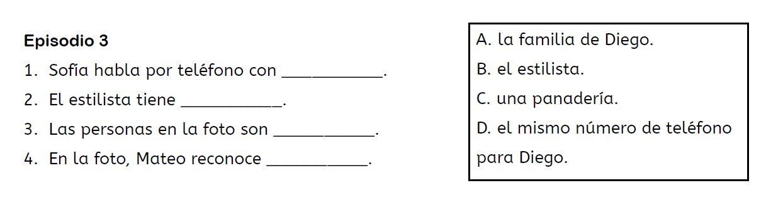Match the information for T1 E3 & T1 E4 - then write the complete translation for each sentence below the corresponding matching activity.



1. Sofia talks on the phone with the hairstylist.



2. The hairstylist has the same phone number for Diego.



3. The people in the photo are Diego’s family.

4. In the photo, Mateo recognizes the bakery.

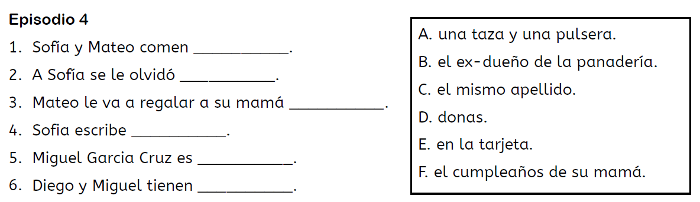



1. Sofia and Mateo eat donuts.

2. Sofia forgets about her mother’s birthday.

3. Mateo is going to give his mother a cup and a bracelet.

4. Sofia writes on the card.

5. Miguel Garcia Cruz is the ex-owner of the bakery.

6. Diego and Miguel have the same last name.